Derrick Fox

CS 136

June 3, 2014

Personal Trainer, Inc.

1. Develop a business profile for Personal Trainer, based on the facts provided.

Personal Trainer Inc. is a company who offers a variety of fitness related products. Throughout their 12 physical locations they offer products that range from tangibles like sportswear, health food, and snacks to intangible products like training classes, access to equipment, and even childcare. Their organization consists of an owner/President, three corporate level managers, a dozen store managers, and soon they will add a 13th manager. Their customer base is a business to consumer relationship consisting of local patrons. They are on the verge of many internet opportunities. They could stand to benefit from an online reservation system for their personal trainers, classes, and day care facilities. This system could also have an online payment system that could even setup automatic reoccurring payments. You could even setup a “reward points” type system. An online facility could also offer a location finder that could then direct you to the nearest of the 13 locations. It could showcase the facilities and their associated functions. Really, the possibilities are endless.

(It is my personal believe that their will soon be what I call “smartbells” which are dumbbells with RFID chips in them so that they can communicate with your smartwatch and tell it exactly how much weight you are lifting. This coupled with the accelerometer will be able to accurately calculate the angle of lift and hence the overall work being done. These statistics could then be posted to the gym’s website to show the gym’s leaders and trends much like what Nike is doing with its Nike+ Fuel system. An online website for a gym could capitalize on this growing trend of community fitness….but this whole idea is another discussion entirely.)

List at least three of Personal Trainer's business processes.

1. Manage accounts

2. Word processing

3. Transaction processing

2. Create an organization chart for Personal Trainer

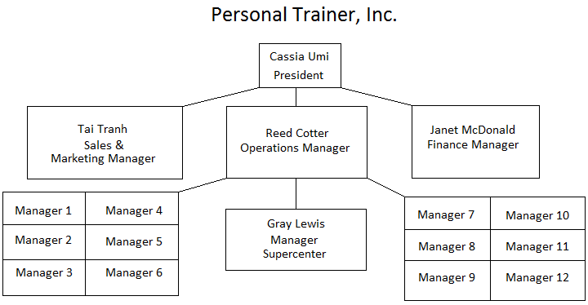

3. Review the conversation between Susan and Gray. In your opinion, is Gray totally supportive of the new system? Why or why not? Do you agree with the way that Susan responds to Gray's comments? Why or why not?

In my opinion, Gray is not very supportive of establishing a new system. At first, he seems content with the current operations and does not feel as though the added features of the new store will warrant the pains of transitioning to a new system. But after the conversation with Susan he seems to be swayed yet still reluctant. I do agree that Susan has a more reasonable vision of Personal Trainer Inc.’s future in that she recognizes that they will undergo an increase in functionality and hence will need to respond with an increase in efficiency.

4. I believe that for the business model of Personal Trainer Inc. they would benefit most from implementing a business support system. At first glance you might be tempted to go with a transaction processing system. But not only can the business support system incorporate a TP system, but Personal Trainer Inc.’s needs are becoming broader than that and a business support system addresses those growing needs. Not only can a system like this process transactions but it can then go deeper and analyze those transactions to depict trends. These trends in inventory, reservation times, spending trends and more can all contribute to making more efficient decisions in an array of fields. Additionally, a system could also take advantage of the RFID chips system I commented on in Question 1 not only to track member’s progress but also to track inventory items as well. I believe Personal Trainer Inc. stands to benefit from a number of online facilities like a reservation system, a payment system, a blog for training tips, a live calendar of events specific to each location, and much more. The benefits for an online resource do not even stop with the customer, for it can also be beneficial is a B2B respect as well. What if it were a common trend that every now and then one of the stores ordered too much of a certain product from the wholesaler and they could not sell it all at a profitable rate? With an online website geared towards other businesses, another business could see Personal Trainer’s website is selling the excess product at discount. So now Personal Trainer could recuperate some of their loses and the other business benefits from purchasing the product at discount. So an online resource could present these win-win scenarios for B2B as well.